CCP-II Model - PINN

Model Description
The one-dimensional capacitively coupled plasma (CCP) model is governed by two fundamental equations: the electron continuity equation and the Poisson equation. The electron continuity equation expresses particle conservation, indicating that electron density evolves over time due to electron transport toward the surfaces and local generation or loss through chemical reactions. The Poisson equation, on the other hand, describes how the electrostatic potential spatially varies in response to the charge distribution of electrons and ions within the plasma. These governing equations are formulated as follows:
Poisson Equation
$$\frac{∂^{2}φ}{∂x^{2}}=\frac{e}{ε_{0}}\left(n_{e}−n_{io}\right)$$
Continuity Equation
$$\frac{∂n_{e}}{∂t}+\frac{∂Γ_{e}}{∂x}=R$$
Here $$n_{e}\left(x,t\right)$$ and $$φ\left(x,t\right)$$ represent the electron density and electric potential, respectively — the primary variables solved for in these equations. The operator denotes the partial derivative with respect to the variable $$x$$. The electron flux, $$Γe​,$$consists of two components: a diffusion flux and a drift flux, defined as follows:
$$Γ_{e}=D\frac{∂n_{e}}{∂x}-μn_{e}\frac{∂ϕ}{∂x}$$
Where $$D$$and $$μ$$ represent the electron diffusion coefficient and electron mobility, respectively. The diffusion coefficient is defined as $$D=\frac{eT_{e}}{m_{e}θ_{m}}$$, and the mobility is given by $$μ=\frac{e}{m_{e}θ_{m}}$$. Here, $$e, T_{e}, m_{e},$$ and $$θ_{m}$$ denote the elementary charge, electron temperature, electron mass, and collision frequency, respectively.
The ion density is expressed as
$$n_{io}=R_{0}\left(x_{2}−x_{1}\right)\sqrt{\frac{m_{i}}{eT_{e}}}$$
Where $$R\left(x\right)$$ and $$R_{0}$$ denote the spatially varying reaction rate and its reference coefficient, respectively. The reaction rate $$R\left(x\right)$$ is a spatially dependent function defined as follows:
$$R\left(x\right) = \left\{R_{0}, x ∈ \left[x_{1},x_{2}\right]∪\left[L−x_{1}, L−x_{2}\right]\right\}\left\{0,otherwise\right\}$$
The boundary conditions are specified as,
$$ne=0,φ=0, at x=0,$$
$$ne=0,φ=V\left(t\right) at x=L,$$
Where $$V\left(t\right)=V_{0}\sin\left(2πft\right)$$.

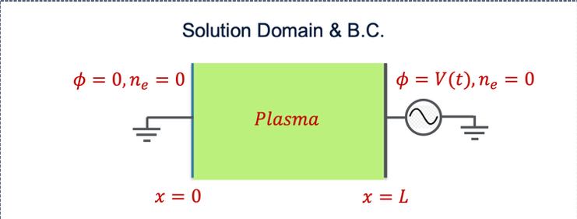
Figure 1: Solution domain and BC for 1D CCP

Input Parameters | Baseline values
Domain Length: $L$ | 0.025m
Driving Frequency: $f$ | 13.56MHz
Driving Voltage Amplitude: $V_{0}$ | 100V
Reaction Rate Coefficient: $R_{0}$ | 2.7e20$m^{-3}s^{-1}$
$$x_{1}$$ | 0.005m
$$x_{2}$$ | 0.01
Electron Temperature: $T_{e}$ | 3eV
Ion mass: $m_{i}$ | 40 amu[1 amu = 1.67e-27kg]
Collision Frequency: $ϑ_{m}$ | 1E8$s^{-1}$

Constants | Value
$$e$$ | 1.6e-19C
$$m_{e}$$ | 9.109e-31kg
$$∈_{0}$$ | 8.854e-12$C^{2}{kg}^{-1}m^{-3}s^{2}$

Non-Dimensionalization
Reference scales.
$$L_{ref}=0.025$$
$$T_{ref}=\frac{1}{13.56×{10}^{6}}$$
$$ϕ_{ref}=100$$
$$N_{ref}=1×{10}^{14}$$
- The continuity equation is as follows,
$$\frac{∂n_{e}}{∂t}+\frac{∂}{∂x}\left(D\frac{∂n_{e}}{∂x}−μn_{e}\frac{∂φ}{∂x}\right)=R\left(x\right)$$
Continuity equation after substitution is given below.

$$\frac{N_{ref}}{T_{ref}}\frac{∂\overline{n_{e}}}{∂\overline{t}}+\frac{1}{L_{ref}}\frac{∂}{∂\overline{x}}\left(D\frac{N_{ref}}{L_{ref}}\frac{∂\overline{n_{e}}}{∂\overline{x}}−μ\frac{N_{ref}φ_{ref}}{L_{ref}}\frac{∂\overline{φ}}{∂\overline{x}}\overline{n_{e}}\right)=R\left(x\right)$$
Dividing the equation by $$\frac{N_{ref}}{T_{ref}}$$, the final dimensionless equation becomes,

$$\frac{∂\overline{n_{e}}}{∂\overline{t}}+α\frac{∂^{2\overline{n_{e}}}}{∂{\overline{x}}^{2}}+β\frac{∂}{∂\overline{x}}\left(\overline{n_{e}} \frac{∂\overline{φ}}{∂\overline{x}}\right) = γR\left(x\right)$$
where,
$$α=-\frac{DT_{ref}}{{L_{ref}}^{2}}$$
$$β=\frac{μϕ_{ref}T_{ref}}{{L_{ref}}^{2}}$$
$$γ=\frac{T_{ref}}{N_{ref}}$$
- The Poisson equation is as follows,

$$\frac{∂^{2}φ}{∂x^{2}}=\frac{e}{ε_{0}}\left(n_{e}−n_{io}\right)$$
Poisson equation after substitution is given below.
$$\frac{φ_{ref}}{L_{ref}^{2}}.\frac{∂^{2\overline{φ}}}{∂\overline{x^{2}}}=\frac{eN_{ref}}{ε_{0}}\left(\overline{n_{e}} −\overline{n_{io}}\right)$$

Standard PINNs
Standard Physics-Informed Neural Networks (PINNs) are a class of neural networks designed to solve partial differential equations (PDEs) by embedding the underlying physics laws directly into the loss function.
Instead of relying solely on labeled data, PINNs enforce governing equations (e.g., continuity, Poisson, Navier–Stokes), initial conditions, and boundary conditions during training. The network learns a function $u_{θ}(x,t)$that approximates the true physical field by minimizing the residuals of these physics-based constraints.
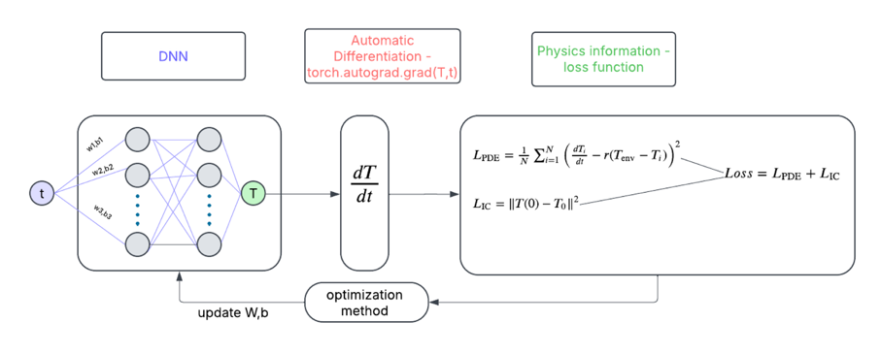
Figure 2: PINN Architecture

Standard PINN for 1D CCP

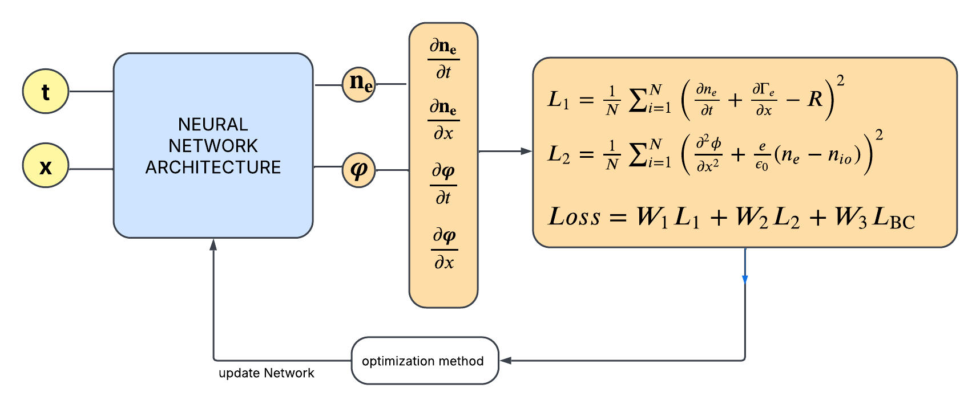
Figure 3: PINN for 1D CCP

Techniques Explored so far

Adaptive weights
Adaptive weighting techniques automatically tune the relative contribution of each loss term during training, allowing the model to balance competing objectives without manual intervention.
$$Loss function = λ_{cont}Loss_{cont}+λ_{pois}Loss_{pois}$$
  - Adaptive weights based on loss variance
This formulation is derived from Kendall and Gal’s (2018) Multi-Task Learning Using Uncertainty to Weigh Losses framework, which interprets each task’s loss as arising from a Gaussian likelihood with a learnable observation noise. In this approach, the model learns a log-variance parameter $w_{i}=\log{σ_{i}^{2}}$ for each task, leading to the composite loss function,
$$L = \sum_{i=1}^{n}{\left(\frac{1}{2}e^{−w_{i}}.loss_{i}+\frac{1}{2}w_{i}\right)}$$

Here, the exponential term $e^{-w_{i}}$acts as an adaptive scaling factor that down-weights noisy or unstable losses (large $w_{i}$) and up-weights reliable ones (small $w_{i}$).

  - Adaptive weights based on Gradient Pathology - “Understanding and Mitigating Gradient Flow Pathologies in Physics-Informed Neural Networks” (Wang et al., 2021)
This approach adjusts loss weights using gradient information to address imbalances and conflicts between multiple objectives during PINN training. Instead of relying on loss magnitudes, it monitors gradient norms to maintain balanced optimization across all terms. By equalizing gradient contributions, these methods mitigate stiffness and vanishing gradient issues, leading to more stable convergence.
Algorithm 1:
Gradient magnitudes:
$$\left|∇L_{cont}\right| = \frac{1}{n}\sum_{i=1}^{n}{\left|\frac{∂L_{cont}}{∂θ_{i}}\right|},$$
$$\left|∇L_{pois}\right| = \frac{1}{n}\sum_{i=1}^{n}{\left|\frac{∂L_{pois}}{∂θ_{i}}\right|},$$

Maximum gradients across tasks:
$$G_{max} = \max_{i}\left(\left|\frac{∂L_{cont}}{∂θ_{i}}\right|,\left|\frac{∂L_{pois}}{∂θ_{i}}\right|\right)$$
Normalized gradient based weights:
$$\overline{λ_{cont}} =\frac{G_{max}}{\left|∇L_{cont}\right|+ε}$$
$$\overline{λ_{pois}} =\frac{G_{max}}{\left|∇L_{pois}\right|+ε}$$
Exponential moving average update:
$$λ_{t }=\left(1−α\right).λ_{t−1}+α.\overline{λ_{t}}$$
Task-specific smoothing updates:
$$λ_{cont}^{\left(t\right)}=\left(1−α\right)λ_{cont}^{\left(t−1\right)}+α\overline{λ_{cont}}$$
$$λ_{pois}^{\left(t\right)}=\left(1−α\right)λ_{pois}^{\left(t−1\right)}+α\overline{λ_{pois}}$$
Algorithm 2:
$$λ_{cont, pois}=\frac{\left|\left|∇_{θ}L_{cont}\left(θ\right)\right|\right|+\left|\left|∇_{θ}L_{pois}\left(θ\right)\right|\right|}{\left|\left|∇_{θ}L_{cont,pois}\left(θ\right)\right|\right|}$$

1.3 Adaptive weights based on Neural Tangent Kernal (NTK) Perspective - Wang et al. (2022)
From the Neural Tangent Kernel (NTK) viewpoint, the convergence behavior of different loss terms in PINNs is governed by their corresponding kernel spectra and coupling strength. Adaptive weighting based on NTK analysis aims to balance the effective learning dynamics across loss components (e.g., PDE residual, boundary, and data terms) by equalizing their contribution to the overall kernel evolution. When one sub-kernel (such as the PDE term) has a much smaller trace or condition number than others, it leads to stiffness and slow convergence. NTK-based adaptive schemes therefore adjust loss weights dynamically to compensate for this imbalance—effectively rescaling gradient updates so that all physics constraints evolve at comparable learning rates.
Under Gradient flow:
$$\frac{dθ}{dt}=-∇_{θ}L\left(θ\right)$$
The residual dynamics follow:
$$\left[\frac{\frac{dR_{c}}{dt}}{\frac{dR_{p}}{dt}}\right]=−\left[\frac{K_{cc}\left(t\right) K_{cp}\left(t\right)}{K_{pc}\left(t\right) K_{pp}\left(t\right)}\right]\left[\frac{R_{c}}{R_{p}}\right]$$

$K_{cc}=J_{c}J_{c}^{\text{T}} where J_{c}=\frac{∂R_{c}}{∂θ}$,

$K_{pp}=J_{p}J_{p}^{\text{T}} where J_{p}=\frac{∂R_{p}}{∂θ}$, and $K_{cp}=J_{c}J_{p}^{\text{T}}, K_{pc}=J_{p}J_{c}^{\text{T}}$
Infinite-width limit: As network width $N→∞$, the NTK converges to a deterministic Kernal, and then training is equivalent to Kernal regression with Kernal $K^{*}$.

$$K\left(t\right)≈K\left(0\right)≈K^{*}$$

Network Architectures
2.1 Poisson solver
2.1.1 Numerically hard constraining the Poisson equation on uniform grid:
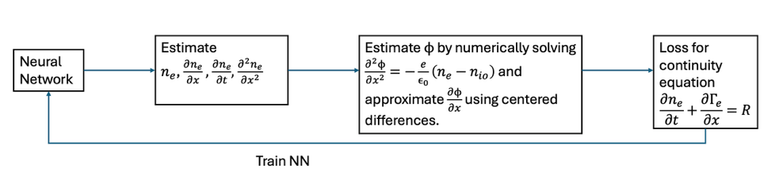
Figure 4: Architecture for uniform grid Poisson solver
2.1.2 Numerically hard constraining the Poisson equation for random collocation points:
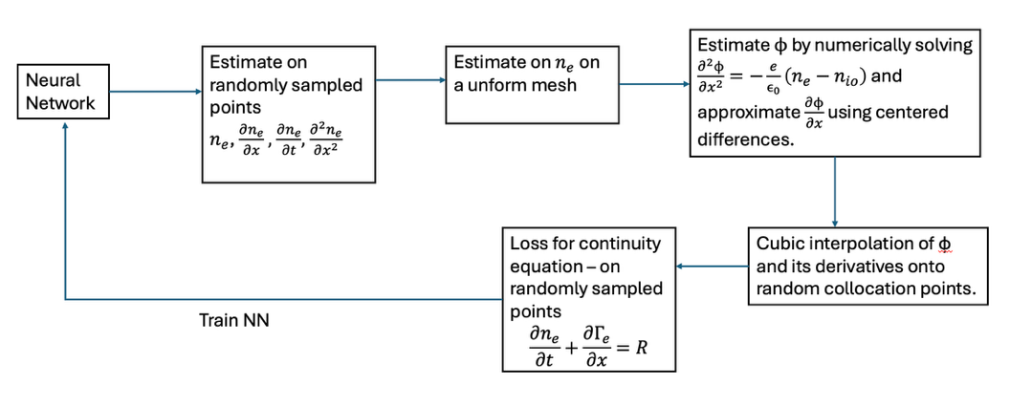
Figure 5: Architecture for Poisson solver - Random collocation points
Poisson solver:
$$φ_{i}^{′′}≈\frac{φ_{i+1}−2φ_{i}+φ_{i−1}}{∆x^{2}}$$
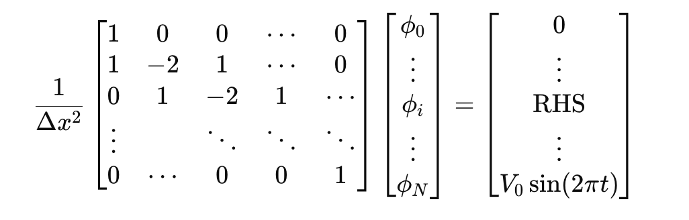
$$Lϕ=\text{RHS}$$
Approximate $\frac{∂ϕ}{∂x}$ using centered differences at interior points and forward and Backward difference at the boundaries.

$${\left.\frac{∂ϕ}{∂x}\right|}_{x_{i}}≈\frac{ϕ_{i+1}-ϕ_{i-1}}{2Δx}$$
$${\left.\frac{∂ϕ}{∂x}\right|}_{x_{0}}≈\frac{ϕ_{1}-ϕ_{0}}{Δx}$$
$${\left.\frac{∂ϕ}{∂x}\right|}_{x_{N-1}}≈\frac{ϕ_{N-1}-ϕ_{N-2}}{Δx}$$

PirateNets - PirateNets: Physics-informed Deep Learning with Residual Adaptive Networks
(Wang et al., 2024)

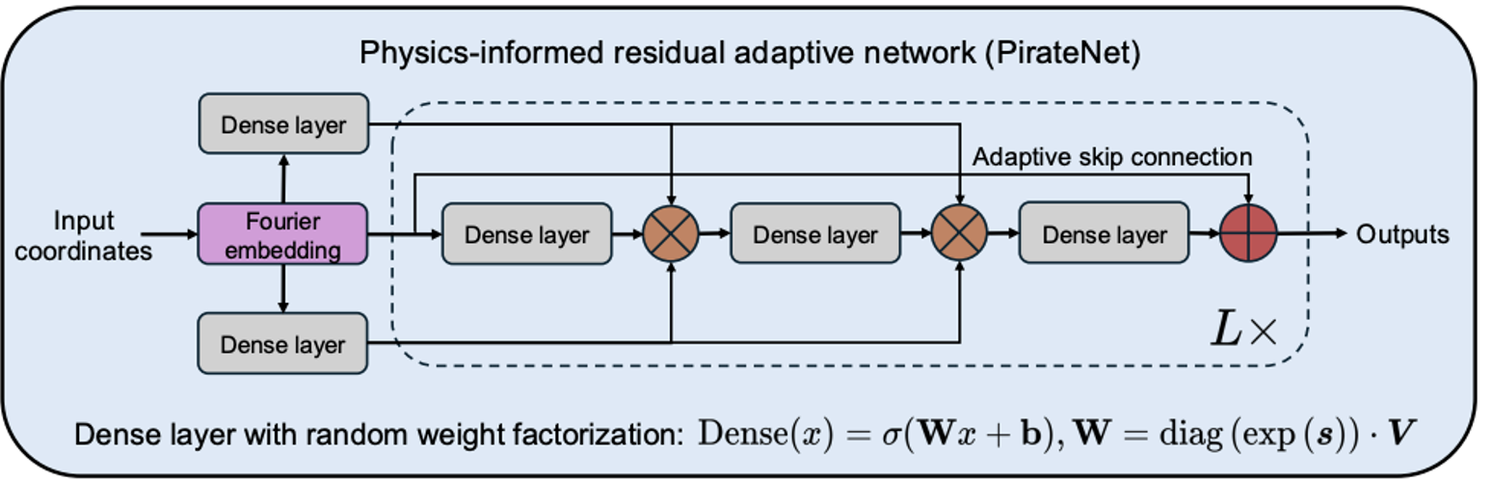
Figure 6: Piratenet Architecture

  - Alternating PINN Architecture
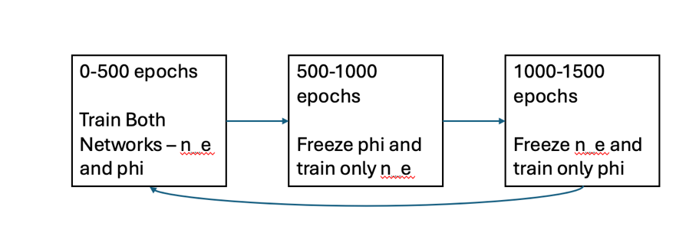
Figure 7: Alternating PINN Architecture

2.4 Hypernetwork Architecture - Hypernetwork-based Meta-Learning for Low-Rank Physics-Informed Neural Networks (Cho et al., NeurIPS 2023)
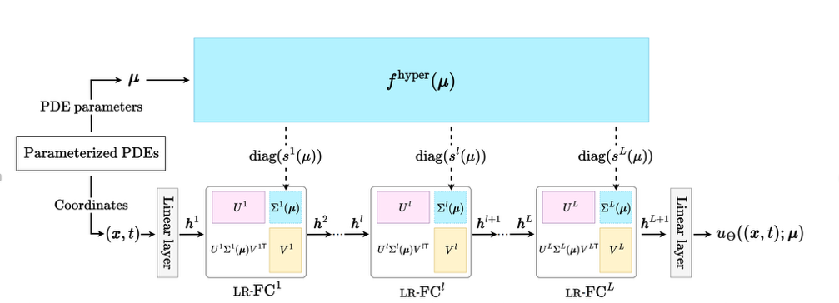
Figure 8: The architecture of Hyper-LR-PINN consisting of (i) the hypernetwork generating model parameters (i.e., diagonal elements) of LR-PINN and (ii) LR-PINN approximating solutions.

Optimizer Strategies
3.1 Config Optimizer - ConFIG: Towards Conflict-free Training of Physics Informed Neural Networks (Liu et al., 2025)
The ConFiG (Conflict-Free Gradient) optimizer addresses gradient conflicts in multi-loss PINN training by projecting each loss gradient onto a common descent direction that minimizes interference. Instead of tuning weights, it geometrically reconciles conflicting gradients, ensuring that all objectives contribute to consistent parameter updates.
3.2 Adam Optimizer combined with L-BFGS - Optimizing the optimizer for physics-informed neural networks and Kolmogorov-Arnold networks (Kiyani et al., 2025)
A hybrid optimization strategy is employed where training begins with the Adam optimizer to provide stable first-order updates and prevent premature convergence in the early training phase. After the model reaches a smoother loss landscape, optimization transitions to the second-order L-BFGS optimizer, which refines the solution with faster convergence and higher precision.

Collocation Point strategies
4.1 Beta Sampling – start from the bulk and gradually increase the points sampled on the sheath
The collocation points are sampled adaptively using a Beta($a,a$) distribution for the spatial coordinate $x$and a uniform distribution for time $t$. When $a<1$, the samples concentrate near the sheath region, while $a>1$emphasizes the bulk plasma region. During training, the parameter $a$is gradually annealed from a higher to a lower value using the update rule dataset.refresh(p=(epoch+1)/(TOTALEPOCHS+1)), progressively shifting focus from the bulk to the sheath.

4.2 RAD sampling – Residual based adaptive distribution - A comprehensive study of non-adaptive and residual-based adaptive sampling for physics-informed neural networks (Wu et al., 2022) [New Addition]
Instead of keeping a fixed collocation grid, it adaptively redistributes training points according to the local magnitude of the PDE residuals. At each resampling step, the method first generates a large candidate pool of random (x,t) points over the spatiotemporal domain. For each candidate point, it evaluates the model’s continuity and Poisson residuals using automatic differentiation and computes a scalar residual magnitude $$ε=\sqrt{R_{cont}^{2}+R_{pois}^{2}}$$. These residuals are then converted into a probability density function,
$$p\left(x,t\right)∝\frac{ε^{k}}{E\left[ε^{k}\right]}​+c,$$
where k controls how strongly the algorithm focuses on regions with large residuals and ccc ensures a uniform sampling component for exploration. The algorithm samples a new set of collocation points from this weighted distribution, effectively allocating more training points to regions where the PDE residuals are higher (i.e., underfitted regions).

Training strategies studied
5.1 Soft constraining vs hard constraining Boundary conditions
Soft constraining:
$$Loss Function = Loss_{cont}+Loss_{pois}+Loss_{BC}$$
Exact Boundary conditions:
For Dirichlet Boundary Conditions, the solution is approximated by:
$$u(x)=g(x) + ϕ(x)\tilde{u}(x) \text{in }Ω, ∂Ω$$
$g(x)$: Known Boundary Condition (satisfies $u(x)=g(x)$ on $∂Ω$)
$ϕ(x)$: Approximate Distance Function
$\tilde{u}(x)$: Trainable Function (NN) that learns the residual structure of the solution inside the domain
Electron Density,
$$n_{e}=x(1-x)*\tilde{n_{e}}$$
Electric Potential,
$$ϕ=(x/1)*V_{0}sin(2πft)+x*(1-x)*\tilde{ϕ}$$

5.2 Time marching approach
The temporal domain $[0,1]$is divided into ten sub-windows of equal length (0.1), and a separate PirateNet model is trained for each window using Random Fourier Feature (RFF) embeddings with hidden dimension $2m+2$and three residual blocks. Each network is initialized by fitting its final linear layer via least squares on boundary samples to satisfy Dirichlet conditions at $x=0$and $x=1$. The training loss per window combines boundary MSE, PDE residuals (continuity and Poisson terms), and an initial condition consistency term that enforces continuity with the previous window’s prediction. The first window additionally includes full-grid FDM supervision to anchor the temporal evolution. During training, 20,000 collocation points are sampled per epoch, evenly split between boundary and interior points. Optimization uses the SOAP optimizer with $β=(0.9,0.999)$, a fixed learning rate of $1×{10}^{-4}$, and weight decay of 0.01. After each window’s training, the model’s prediction at $t=t_{\text{end}}$serves as the initial condition for the next window, enabling stable time-marching evolution across the full temporal domain.
5.3 Curriculum Training strategy [New Addition]
the model is not trained from scratch for every new parameter configuration, but instead builds upon a previously learned solution. After identifying the parameter setting that produced the lowest L2 error (in this case, a reaction coefficient of 2.5×e20, the corresponding trained network is used as the initialization for subsequent training runs. The model is then fine-tuned sequentially as the reaction coefficient (or other physical parameters such as driving voltage) is gradually increased — e.g., 2.5×e20→2.7×e20→2.9×e20→3.5×e20.
5.3.1 Curriculum Training strategy [New Addition 1]

To stabilize training across successive curriculum stages, we adopted an output-layer-only fine-tuning strategy. In this approach, the neural network weights learned from the previous stage (corresponding to a lower reaction-rate coefficient R0 or voltage V0) are reused as initialization for the next stage. However, during the subsequent fine-tuning phase, all network parameters except the final linear output layer are frozen (i.e., their gradients are disabled). Only the weights and biases of the output layer remain trainable.

5.4 Bounding Potential [New Addition 2]
To prevent the potential field ϕ\phiϕ from evolving too rapidly during training and producing overly diffused or unstable solutions, we introduced a learnable gating mechanism on the output of the potential head. Specifically, the final predicted potential is expressed as
$$φ\left(x,t\right)=x\sin\left(2πt\right)+x\left(1−x\right)\left(Softplus\left(g_{φ}​\right)⋅φ_{head}​\left(x,t\right)\right),$$
Where $$g_{φ}$$is a trainable scalar parameter and $$Softplus\left(g_{φ}\right)=\ln\left(1+e^{g_{φ}}​\right)$$ ensures that the scaling factor remains positive and smoothly adjustable.

Other Features
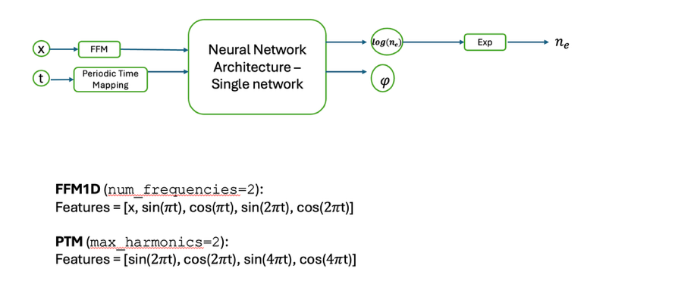
Figure 9: Full PINN Architecture
6.1 Fourier Feature mapping
Fourier Feature Mapping transforms input $x∈R^{2}$ into a higher dimensional space using sinusoidal functions:
$$\text{γ(}x\text{)=[}x{,sin⁡(2}^{0}πx)\text{, }{cos⁡(2}^{0}πx)\text{, …, }{sin⁡(2}^{L-1}πx)\text{, }{cos(2}^{L-1}πx)\text{]}$$
6.2 Periodic Time Embedding to enforce Quasi-Steady state.
PTM (max_harmonics=2):
Features = [sin($2π$t), cos($2π$t), sin($4π$t), cos($4π$t)]
6.3 Predicting log($n_{e}$) instead of $n_{e}$ directly.
Adding exponential transformation on the output.

Evaluation Critera
7.1 L2 Error
$$L2 Error = \frac{\sqrt{\sum_{i=1}^{n}{{\left(u_{pred}−u_{GT}\right)}^{2}}}}{\sqrt{\sum_{i=1}^{n}{u_{GT}^{2}}}}​​$$
7.2 FRMSE (Fourier Mean square Error) [New Addition]
We computed the Fourier Root Mean Square Error (FRMSE) along both the spatial (xxx) and temporal (ttt) domains. Unlike the standard RMSE, which measures pointwise discrepancies in the physical domain, FRMSE quantifies differences in the frequency domain, allowing assessment of how well the model preserves the true spectral content (i.e., oscillatory modes and harmonics) of the plasma dynamics. For each fixed time slice, the spatial FRMSE is obtained by applying a Fast Fourier Transform (FFT) along xxx to both the predicted and reference signals and then calculating the root-mean-square deviation between their spectra—either comparing the full complex spectra (amplitude + phase) or only magnitudes when phase jitter is negligible. This process is repeated over all time slices, and the average yields a single spatial FRMSE metric. Similarly, the temporal FRMSE is computed by performing FFTs along ttt for each spatial location, providing a measure of how accurately the model reproduces the temporal oscillation frequencies (e.g., RF cycles and harmonics). In both cases, the error is normalized by the spectral energy of the true field to obtain a dimensionless, scale-invariant measure.

Results
Current Best Results – uses [1.2 Adaptive weights based on gradient pathology – Algorithm1, 5.1 Exact Boundary conditions, 6.1 FFM, 6.2 Periodic Time Embedding, 6.3 log($n_{e}$)]

Results without using FDM data
Reaction Coefficients | L2 electron density – W/O exp and W/O periodicity | L2 electron density – W/O periodicity | L2 electron density – with periodicity | L2 electron potential – W/O exp and W/O periodicity | L2 potential – W/O periodicity | L2 potential – with periodicity
2.3e20 | 2.73e-1 | 1.0522e-1 | 3.0539e-02 | 5.60e-1 | 1.605e-1 | 5.3093e-02
2.5e20 | 9.72e-2 | 1.0922e-1 | 3.1364e-02 | 1.49e-1 | 1.770e-1 | 4.3508e-02
2.7e20 | 3.55e-2 | 9.1419e-02 | 3.8642e-02 | 3.89e-2 | 2.3606e-01 | 4.7239e-02
2.9e20 | 3.46e-1 | 1.2765e-1 | 5.1740e-02 | 9.75e-1 | 2.3527e-1 | 7.1187e-02
3.1e20 | 3.38e-1 | 1.3547e-1 | 6.4765e-02 | 9.59e-1 | 2.6225e-01 | 9.9661e-02
3.3e20 | 2.76e-1 | 1.4744e-01 | 7.4213e-02 | 7.23e-1 | 2.9969e-01 | 1.2266e-01
3.5e20 | 3.35e-1 | 1.5859e-01 | 8.9514e-02 | 1.04 | 3.3580e-01 | 1.5874e-01
3.7e20 | 2.36e-1 | 1.6237e-01 | 9.9256e-02 | 5.93e-1 | 3.5418e-01 | 1.8283e-01
3.9e20 | 4.07e-1 | 1.6113e-01 | 1.0422e-01 | 1.55 | 3.5708e-01 | 1.9687e-01

Voltage | L2 electron density – with periodicity | L2 potential – with periodicity
40 | 4.5911e-02 | 1.1122e-01
60 | 4.0287e-02 | 7.0022e-02
80 | 4.2982e-02 | 6.2883e-02
125 | 4.3440e-02 | 4.3700e-02
150 | 2.5862e-01 | 4.7727e-01

Results with FDM data [0,0.1]
Reaction Coefficient | L2 electron density – with periodicity | L2 potential – with periodicity
2.3e20 | 1.2517e-01 | 2.2103e-01
2.5e20 | 5.3211e-02 | 7.3642e-02
2.7e20 | 4.6132e-02 | 6.1928e-02
2.9e20 | 5.6219e-02 | 8.2813e-02
3.1e20 | 3.5733e-02 | 4.1231e-02
3.3e20 | 3.9818e-02 | 5.0115e-02
3.5e20 | 4.8941e-02 | 6.9657e-02
3.7e20 | 5.5340e-02 | 8.3435e-02
3.9e20 | 6.0378e-02 | 9.6356e-02

Voltage | L2 electron density – with periodicity | L2 potential – with periodicity
40 | 3.5876e-02 | 8.5490e-02
60 | 2.6507e-02 | 4.3612e-02
80 | 2.7162e-02 | 3.9433e-02
120 | 2.0405e-01 | 4.3361e-01
140 | 2.8225e-01 | 5.9934e-01

Curriculum Learning results – starting point 2.5e20 - (without using FDM data) phase2 – trained only for 10k epochs
Reaction Coefficient | L2 electron density – with periodicity | L2 potential – with periodicity
2.7e20 | 4.2846e-02 | 5.2608e-02
2.9e20 | 5.4144e-02 | 7.4905e-02
3.1e20 | 6.9065e-02 | 1.0821e-01
3.3e20 | 8.1593e-02 | 1.3801e-01
3.5e20 | 9.3149e-02 | 1.6614e-01
3.7e20 | 9.5834e-02 | 1.7446e-01
3.9e20 | 1.0189e-01 | 1.9120e-01

– starting point 100 - (without using FDM data)
Voltage | L2 electron density – W/O Curriculum Learning | L2 electron density – with curriculum learning | L2 potential – W/O Curriculum Learning | L2 potential – with curriculum learning
40 | 4.5911e-02 | 3.8641e-02 | 1.1122e-01 | 8.6708e-02
60 | 4.0287e-02 | 4.3498e-02 | 7.0022e-02 | 7.8053e-02
80 | 4.2982e-02 | 3.8519e-02 | 6.2883e-02 | 5.2650e-02
125 | 4.3440e-02 | 4.3428e-02 | 4.3700e-02 | 4.4351e-02
150 | 2.5862e-01 | 1.2771e-01 | 4.7727e-01 | 1.5624e-01

Prediction Error, Training loss analysis and FRMSE
- For Rection Coefficient 2.7e20 and Voltage 100 – Trained wth FDM data [0,0.1] – After training for 50k epochs

Error Plot (FDM - Prediction)
L2 error for electron density - 4.6132e-02
L2 error for electric potential - 6.1928e-02
Contour Plot of Loss Function (PDE Equation Loss)
Continuity loss: 14.545
Poisson loss: 0.1183
FRMSE – Fourier Mean Square Error – with respect to FDM solution
FRMSE Along x
Spectral FRMSE(ne): 0.004917
Spectral FRMSE(phi): 0.017183349512342676

FRMSE Along t
FRMSE(ne) averaged over x: 0.000273

FRMSE(phi) averaged over x: 0.000247

RAD Collocation point strategy results
Electron Density prediction L2 error: 5.3004e-02 ( previous: 3.8642e-02)
Potential prediction L2 error: 6.9764e-02 (previous 4.7239e-02)
Spectral FRMSE(ne) over time: 0.006877
Spectral FRMSE(phi) over time: 0.0149

Contour Plot of Loss Function (PDE Equation Loss)
Continuity loss: 9.1346 (previous best 14.545)
Poisson loss: 0.0111 (previous best 0.1183)

Curriculum Learning Results [new]
Starting point 2.3e20 with voltage 40.
L2 error for electron density: 1.8609e-02
L2 error for potential: 4.1788e-02
MSE Continuity Equation: 6.0938e+00
MSE Poisson Equation: 9.2989e-02
Results for full parameters training across voltages
Phase 2: 200 epochs
R0 | V0 | L2_ne | L2_phi | MSE_cont | MSE_pois
2.3e+20 | 50 | 3.161566e-02 | 5.636217e-02 | 2.488055e+01 | 1.304905e+00
2.3e+20 | 60 | 3.916706e-02 | 6.344755e-02 | 5.961906e+01 | 1.029840e+00
2.3e+20 | 70 | 4.492822e-02 | 6.620672e-02 | 9.725822e+01 | 5.233031e-01
2.3e+20 | 80 | 4.483469e-02 | 5.883364e-02 | 1.324737e+02 | 3.974405e-01
2.3e+20 | 90 | 4.638432e-02 | 5.465768e-02 | 1.876269e+02 | 3.013325e-01
2.3e+20 | 100 | 4.342737e-02 | 4.676372e-02 | 2.460074e+02 | 2.481982e-01
2.3e+20 | 110 | 4.413664e-02 | 4.367324e-02 | 3.060362e+02 | 2.494961e-01
2.3e+20 | 120 | 4.171706e-02 | 4.109157e-02 | 3.878161e+02 | 2.367679e-01
2.3e+20 | 130 | 4.199143e-02 | 3.977207e-02 | 4.872361e+02 | 2.215803e-01
2.3e+20 | 140 | 4.025070e-02 | 4.194104e-02 | 6.833444e+02 | 1.474459e-01
2.3e+20 | 150 | 4.006717e-02 | 4.506087e-02 | 8.670740e+02 | 9.107627e-02
2.3e+20 | 160 | 4.074246e-02 | 4.722852e-02 | 9.737412e+02 | 7.805082e-02
2.3e+20 | 170 | 4.229842e-02 | 5.226039e-02 | 1.076932e+03 | 7.296867e-02
2.3e+20 | 180 | 4.402554e-02 | 5.382870e-02 | 1.256427e+03 | 5.640165e-02
2.3e+20 | 190 | 4.636328e-02 | 5.716229e-02 | 1.388295e+03 | 5.217274e-02
2.3e+20 | 200 | 4.945816e-02 | 6.099819e-02 | 1.516249e+03 | 4.917224e-02

Phase 2: 10000 epochs
R0 | V0 | L2_ne | L2_phi | MSE_cont | MSE_pois
2.3e+20 | 50 | 2.807374e-02 | 5.012997e-02 | 4.797244e+00 | 3.851635e-02
2.3e+20 | 60 | 2.894326e-02 | 4.938496e-02 | 5.514805e+00 | 2.556523e-02
2.3e+20 | 70 | 3.140317e-02 | 4.896793e-02 | 6.284980e+00 | 1.794200e-02
2.3e+20 | 80 | 3.192281e-02 | 4.859791e-02 | 6.915970e+00 | 1.190310e-02
2.3e+20 | 90 | 3.437752e-02 | 4.703597e-02 | 7.156081e+00 | 7.140536e-03
2.3e+20 | 100 | 3.534235e-02 | 4.616679e-02 | 7.329617e+00 | 5.632782e-03
2.3e+20 | 110 | 3.698132e-02 | 4.430815e-02 | 7.404782e+00 | 4.324346e-03
2.3e+20 | 120 | 3.673596e-02 | 4.379927e-02 | 7.734769e+00 | 3.468214e-03
2.3e+20 | 130 | 3.837408e-02 | 4.176474e-02 | 8.108567e+00 | 2.756293e-03
2.3e+20 | 140 | 3.862646e-02 | 4.094258e-02 | 8.373223e+00 | 2.147563e-03
2.3e+20 | 150 | 3.948574e-02 | 3.991338e-02 | 8.867505e+00 | 1.798011e-03
2.3e+20 | 160 | 4.040982e-02 | 3.883026e-02 | 9.163703e+00 | 1.542275e-03
2.3e+20 | 170 | 4.051710e-02 | 3.949747e-02 | 9.681959e+00 | 1.326789e-03
2.3e+20 | 180 | 4.187272e-02 | 3.846046e-02 | 1.015721e+01 | 1.226434e-03
2.3e+20 | 190 | 4.229562e-02 | 3.875002e-02 | 1.090896e+01 | 1.103609e-03
2.3e+20 | 200 | 4.296246e-02 | 3.970936e-02 | 1.141581e+01 | 1.006440e-03

Results for full parameters training across Reaction Coefficients
Phase 2: 200 epochs
R0 | V0 | L2_ne | L2_phi | MSE_cont | MSE_pois
2.4e+20 | 40 | 2.009708e-02 | 3.565454e-02 | 7.959467e+00 | 2.371040e-01
2.5e+20 | 40 | 2.299866e-02 | 3.558987e-02 | 1.001456e+01 | 7.736481e-01
2.6e+20 | 40 | 2.466635e-02 | 4.014197e-02 | 1.330037e+01 | 5.822570e-01
2.7e+20 | 40 | 2.826826e-02 | 5.103452e-02 | 1.611945e+01 | 7.961875e-01
2.8e+20 | 40 | 3.118877e-02 | 6.285283e-02 | 2.049892e+01 | 8.246357e-01
2.9e+20 | 40 | 3.507965e-02 | 7.681153e-02 | 2.474391e+01 | 1.109400e+00
3.0e+20 | 40 | 3.764818e-02 | 8.859932e-02 | 3.170441e+01 | 1.060857e+00
3.1e+20 | 40 | 4.275549e-02 | 1.036229e-01 | 3.517272e+01 | 2.300250e+00
3.2e+20 | 40 | 4.452226e-02 | 1.124223e-01 | 4.385348e+01 | 2.412745e+00
3.3e+20 | 40 | 4.727232e-02 | 1.211887e-01 | 4.977001e+01 | 3.660812e+00
3.5e+20 | 40 | 5.049982e-02 | 1.321800e-01 | 7.042947e+01 | 7.913837e+00
3.6e+20 | 40 | 4.889476e-02 | 1.324056e-01 | 8.890766e+01 | 5.864219e+00
3.7e+20 | 40 | 4.692605e-02 | 1.317072e-01 | 1.151553e+02 | 4.153815e+00
3.8e+20 | 40 | 4.697364e-02 | 1.338962e-01 | 1.287294e+02 | 4.402046e+00
3.9e+20 | 40 | 4.859686e-02 | 1.384237e-01 | 1.440640e+02 | 7.352628e+00

Phase 2: 10000 epochs
R0 | V0 | L2_ne | L2_phi | MSE_cont | MSE_pois
2.4e+20 | 40 | 2.530618e-02 | 4.599390e-02 | 5.403788e+00 | 9.556749e-02
2.5e+20 | 40 | 3.398694e-02 | 6.962656e-02 | 4.865795e+00 | 1.005018e-01
2.6e+20 | 40 | 4.194619e-02 | 9.598253e-02 | 4.635869e+00 | 1.058317e-01
2.7e+20 | 40 | 4.894746e-02 | 1.211198e-01 | 4.677203e+00 | 1.169817e-01
2.8e+20 | 40 | 5.598176e-02 | 1.474981e-01 | 4.653391e+00 | 1.347220e-01
2.9e+20 | 40 | 6.284615e-02 | 1.741898e-01 | 4.661182e+00 | 1.567057e-01
3.0e+20 | 40 | 6.871374e-02 | 1.980231e-01 | 4.682320e+00 | 1.700474e-01
3.1e+20 | 40 | 7.339858e-02 | 2.179162e-01 | 4.958564e+00 | 1.864582e-01
3.2e+20 | 40 | 7.734144e-02 | 2.354747e-01 | 5.141104e+00 | 2.035254e-01
3.3e+20 | 40 | 8.127583e-02 | 2.535486e-01 | 5.202259e+00 | 2.175645e-01
3.5e+20 | 40 | 8.610441e-02 | 2.783858e-01 | 5.914677e+00 | 2.862919e-01
3.6e+20 | 40 | 8.692482e-02 | 2.851740e-01 | 6.387252e+00 | 2.789694e-01
3.7e+20 | 40 | 8.858517e-02 | 2.953484e-01 | 6.765526e+00 | 2.853732e-01
3.8e+20 | 40 | 9.119346e-02 | 3.099262e-01 | 6.740652e+00 | 2.962980e-01
3.9e+20 | 40 | 9.330003e-02 | 3.227281e-01 | 6.825350e+00 | 3.076882e-01

Results for training only the output layer in phase 2 across reaction coefficients [section 5.3.1] - 10k epochs
R0 | L2_ne-full | L2_ne-only output | L2_potential-full | L2_potential- only output
2.4e+20 | 2.530618e-02 | 2.648810e-02 | 4.599390e-02 | 4.823044e-02
2.5e+20 | 3.398694e-02 | 3.554892e-02 | 6.962656e-02 | 6.187380e-02
2.6e+20 | 4.194619e-02 | 4.413994e-02 | 9.598253e-02 | 8.528619e-02
2.7e+20 | 4.894746e-02 | 5.218491e-02 | 1.211198e-01 | 1.077226e-01
2.8e+20 | 5.598176e-02 | 6.015672e-02 | 1.474981e-01 | 1.308429e-01
2.9e+20 | 6.284615e-02 | 6.806211e-02 | 1.741898e-01 | 1.542222e-01
3.0e+20 | 6.871374e-02 | 7.575777e-02 | 1.980231e-01 | 1.773259e-01
3.1e+20 | 7.339858e-02 | 8.288746e-02 | 2.179162e-01 | 1.992170e-01
3.2e+20 | 7.734144e-02 | 8.929926e-02 | 2.354747e-01 | 2.185659e-01

Results for training only the output layer in phase 2 across voltages [section 5.3.1] - 10k epochs
V0 | L2_ne-full | L2_ne-only output | L2_potential-full | L2_potential- only output
50 | 2.807374e-02 | 2.365605e-02 | 5.012997e-02 | 4.414828e-02
60 | 2.894326e-02 | 4.691376e-02 | 4.938496e-02 | 8.980975e-02
70 | 3.140317e-02 | 8.244538e-02 | 4.896793e-02 | 1.604380e-01
80 | 3.192281e-02 | 1.120686e-01 | 4.859791e-02 | 2.103008e-01
90 | 3.437752e-02 | 1.333411e-01 | 4.703597e-02 | 2.318215e-01
100 | 3.534235e-02 | 1.644843e-01 | 4.616679e-02 | 2.693145e-01
110 | 3.698132e-02 | 1.881880e-01 | 4.430815e-02 | 2.858760e-01

Other studied References
7.1 Preconditioning - An operator preconditioning perspective on training in physics-informed machine learning – (Ryck et al.,)

